Демонстрационный вариант промежуточной аттестации по английскому языку 2022.
7 класс.
Grammar: Present Simple, Future Simple, Past Simple, Past Continuous, Present Perfect.
Vocabulary: gadgets(p.48), fun activities(p.56), teen camp activities with go/have/make/play(p.58). Phrasal verbs: go, look, come

1.Complete the words.
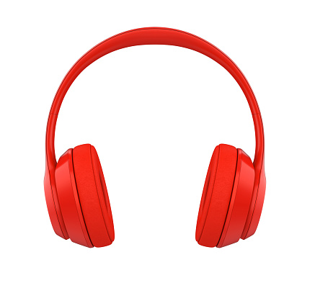 | 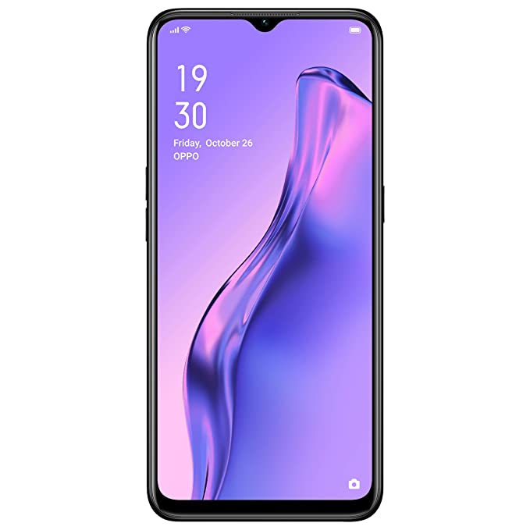 | 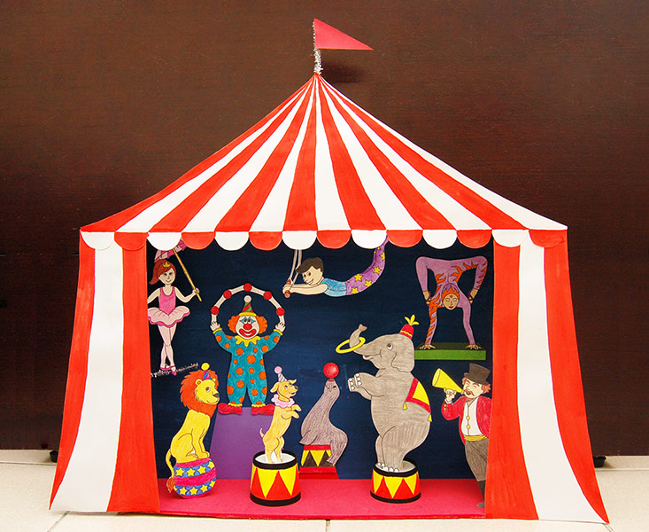 |  | 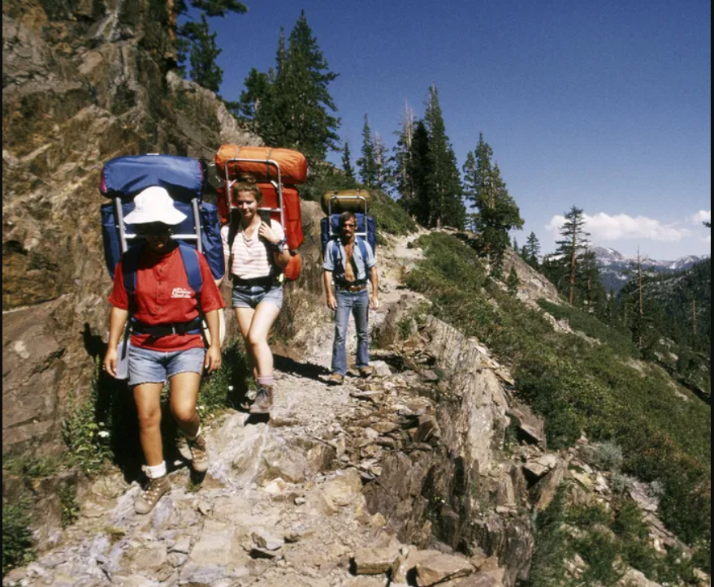
H_ _ _p_ _ _ _ _ s | _ _b_ _e _h_ _n_ | _ _ r_ _s | R_ _l_ _ _o_ _ t_ _ _ | _i_ _ _g

2. FIll the gaps with the words below.
Button, hiking, laptop, rollercoaster, ghosts.
1. It’s much easier to travel with a ….............. than with a PC.
2. Thorp Park is the best place to ride on a ….............................. .
3. Press the ........................... to switch the computer off.
4. You can come across some …......................... in the Haunted Mansion.
5. The campers of Adventure Camp went …................ yesterday

3. Choose the best option.
1. My favourite author’s book …........... soon.
A. will come out B. came out C. has come out
2. I’ll get the dictionary and ….................. the information I don’t know.
A. go on B. look up C. come back
3. Jane …............. rafting every summer.
A. will go B. go C. goes
4. I …........... on my computer at 5 o’clock yesterday.
A. was working B. worked C. has worked
5. We …............ our homework yet.
A. didn’t do B. haven’t done C. were doing
6. Mum ....... me up from the airport last night.
A. was picking B. picked C. is picking
7. I came …........ this poster in the basement.
A. across B.out C. round
8. I’m throwing out the bread because it has gone ....... .
A. on B. off C. with

4. Reading
Online shopping
My name is Sara, and I love shopping online. I prefer mobile phone apps, but sometimes I use my computer. The phone is more convenient for me, and I can even do my shopping from bed!
I love shopping so much that I buy everything I need at home. I get food, electronics, books, and even large pieces of furniture like my sofa and bookshelves all online! But I still prefer getting clothes from a store so I can try them on to be sure they fit me fine.
Yesterday, I bought a birthday present for my mother, and it arrived today! That saves me a lot of time. I am a very busy person, and I am a little forgetful too. If I think of something I need, then it is wonderful that I can buy it at that moment.
My friends aren’t as comfortable with buying things online as I am because they think that it can be dangerous. Of course, bad things sometimes happen, but I am very careful with all of my personal details. I think the biggest fear that people have with using their credit cards online is that someone will steal their number. It is important to be sure that the web page is secure. You can see this if the address has got an “s” in it, like https://. That “s” means it is safe.
People should not be afraid of shopping online. I think it will be the only way we will do our shopping in the future!
1. What is Sara’s favourite way of shopping?
a. On her computer.
b.On her phone.
c. In a shop.
2. What doesn’t Sara buy online?
a. Food.
b. Furniture.
c. Clothes.
3. What does “s” in “https” mean?
a. safe
b. shopping
c. steal
4. Sara’s thinks that in the future ...
a. online shopping will be safer.
b. a lot of people will shop online.
c. everybody will only shop online.

